PINpad Setup for Production

Note: If a PINpad is not assigned, skip Step 4a and follow Step 4b.

- Install Miraserv
– Run the setup.exe file located in \\Svbhq015\IT\GIS-Install Utility\GISClientInstallation\EIGEN Miraserv Installation\EigenSDK\setupActiveX.
– Agree to the Terms and Conditions and keep clicking Next until Miraserv is installed.
– Miraserv will be installed in C:\Program Files.

- Stop Miraserv
– Run StopMiraServ.exe in C:\Program Files\Eigen\MiraServ to stop Miraserv.

- Update the Miraserv folder
– Replace the Miraserv folder created in C:\Program Files with the Miraserv folder located in \\Svbhq015\Vol2\IT\GIS-Install-Utility\GISClientInstallation\EIGEN Miraserv Installation\EigenProduction.

4a. (If a PINpad is assigned) Configure Miraserv and the PINpad
– Open the miraserv.ini file in C:\Program Files\Eigen\MiraServ.
– Change NodeID, StationID, TermID and DebitTermID with reference to the VAN Budget Spreadsheet.xls located in \\Svbhq015\vol2\IT\GIS-Install-Utility\GISClientInstallation\EIGEN Miraserv Installation.
– Hook the PINpad up to the COM port of the CSR’s work station (in miraserv.ini, PinPadPort = '1' if you connect the PINpad to the COM port).

NOTE
If the work station does not have a COM port, try the following steps:
a. Connect PINpad to the USB port via a USB serial converter.
b. Install the drivers from \\Svbhq015\IT\GIS-Install-Utility\GISClientInstallation\EIGEN Miraserv Installation\CDM 2.04.16 WHQL Certified\i386.
c. Change PinPadPort in miraserv.ini to '3'.

– Initialize EMV by setting InitEMV to 'Y'.
– Save the file.

4b. (If no PINpad exists) Configure Miraserv
– Open the miraserv.ini file in C:\Program Files\Eigen\MiraServ.
– Change NodeID, StationID and TermID with reference to the VAN Budget Spreadsheet.xls located in \\Svbhq015\vol2\IT\GIS-Install-Utility\GISClientInstallation\EIGEN Miraserv Installation.
– Set DebitTermID to 'NOTERMID'.
– Save the file.

- Start Miraserv
– Run StartMiraServ.exe in C:\Program Files\Eigen\MiraServ to start Miraserv.
– The message displayed on the PINpad will change from
INITIALIZING EMV PLEASE WAIT to INITIALIZING EMV COMPLETE to OPEN.
- Configure GIS
– Open up the GIS configuration file by entering C:\WINDOWS\gis.ini in the Run window to open up gis.ini.
– Ensure that the StationID in miraserv.ini matches the TerminalID in gis.ini.
– Change the Credit Card Provider in gis.ini to EIGEN.
– Save the file.

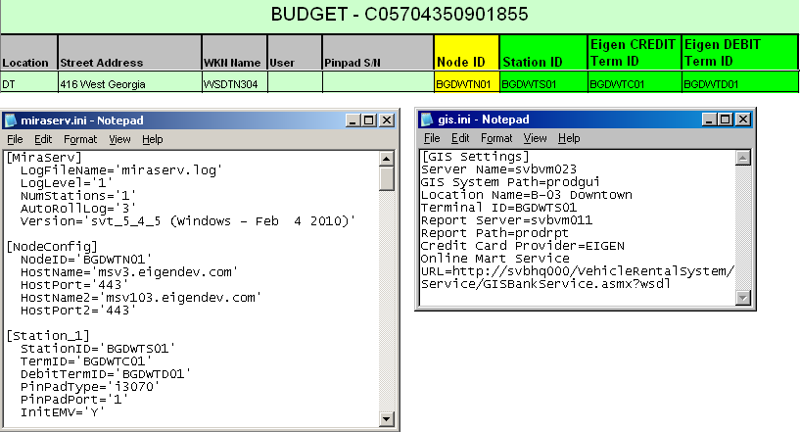
Figure 1: The final look of both .ini files with reference to VAN Budget Spreadsheet.xls.

PINpad Testing

You should test both MiraServ and the PINpad before assigning the new PINpad IDs to production (workstation and servers). Your testing is successful if you see the word “APPROVED” or an Authorization #. Record your test results in the “Test OK” column in the VAN Budget Spreadsheet(18Feb2010).xls located in \\svbhq015\Vol2\IT\GIS-Install-Utility\GISClientInstallation\EIGEN Miraserv Installation.

If you do not have GIS on your computer, execute Step 1a. However, it is recommended that you perform your testing on GIS (See Step 1b).

Note: (1) You must use a valid credit card for testing.
(2) You should print a record of any transaction you tested on GIS for the company’s reference should you charge an amount to your card.

1a. (If there is no GIS) Test PINpad
– Run TestMiraServ.exe in C:\Program Files\Eigen\MiraServ to start MiraX Test.
- Enter the StationID from your miraserv.ini (or gis.ini) in the StationID field.
- In the Transaction Code field, enter 11 (i.e. Authorize).
- Enter an Amount (Please note that this field is in cents, so to process $1.00, enter 100).
- If you do not have a PINpad
- Enter the credit card number and expiry date in their respective fields.
- Leave the Swipe Card option unchecked, and click Process Transaction.
- If you have a PINpad attached to your terminal
- Select the Swipe Card option and click Process Transaction.
- Swipe/insert your credit card using the PINpad.
- Verify that your transaction went through successfully and the approval receipts are shown in both the Merchant and Customer Copy sections, as shown in Figure 2.

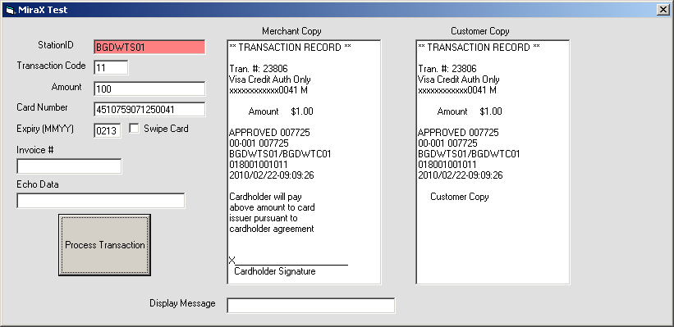
Figure 2: A receipt is displayed upon approval of transaction.
NOTE
Repeat the same steps with your debit card on MiraX Test if you have a PINpad.

1b. (If GIS is installed) Test PINpad
– Log in to GIS and bring up the Contract Open module.
- Populate all fields in the Vehicle Information section and click Get Data.
- Enter all mandatory fields in the Renter and Rate + Coverage tabs.
- In the Payment tab, select ‘Credit Card’ in the Renter Pre-Authorization Method field.
- Enter $1 in the Preauthorization/Deposit Amount field.
- If you do not have a PINpad
- Select the Card Not Swiped/Not Inserted option.
- Manually enter the credit card information.
- Click Authorize.
The display of an Authorization # signals the approval of your transaction.
- If you have a PINpad attached to your terminal
- Click Authorize.
- Swipe/insert your credit card using the PINpad.
The credit card transaction is approved and an Authorization # appears.
- Click Deposit/Refund Record and go to the Cash Deposit/Refund section.
- Select ‘Deposit’ from the +/- column.
- Select ‘Debit Card’ in the Type column.
- Enter $1 in the Amount field and click Collect Payment.
- Swipe/insert your debit card using the PINpad.
A payment record with an Authorization # is added to the grid.
- Select ‘Refund’ from the +/- column.
- Select ‘Debit Card Refund’ in the Type column.
- Enter $1 in the Amount field and click Issue Refund.
- Swipe/insert your debit card using the PINpad.
A refund record with an Authorization # is added to the grid.

